Simple Linear Regression Model. Multiple Choice tests.

- Which of the following is/are not normal equation(s) for the Simple linear regression model coefficients:
I. 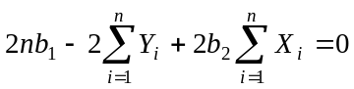 II. 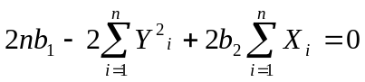
III. 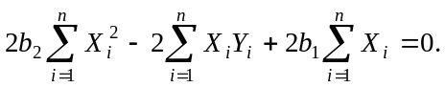 IV. 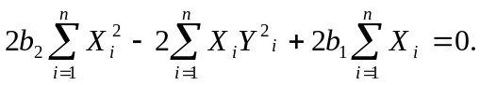
V. 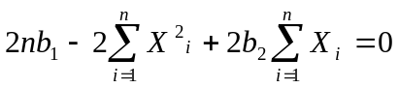

1) I, II, IV and V.
2) I, III and V only.
3) I and V only.
4) I, IV and V only.
5) II, IV and V only.

- If the explanatory variable X in a model of simple linear regression takes the mean value in the sample, 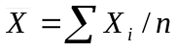, then (indicate the set of true statements):
- the calculated by the regression equation value of dependent variable Y is equal 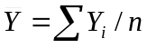;
- the average of all calculated by the regression equation values of dependent variable Y is equal ,
- the observed value of dependent variable Y is equal ;
- Only A 2) only B 3) B and C 4) A and B 5) only C

- How many from the following statements are NOT one of the assumptions of the model A?
- 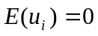 for all observations;
- the dependent variable is a linear function of explanatory variables;
- 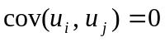 (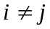);
- 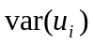 is constant for all observations;
- Four
- Three
- Two
- Only one
- No one

- The estimator of regression coefficient is called consistent if
- it is unbiased and efficient;
- it can be obtained by the method of Least Squares;
- its population variance decreases monotonously with the increase of the number of observations;
- the set of variables and mathematical formula are correctly selected for a model;
- all the above is incorrect.

- Having a sample with data for variables X and Y, a student has estimated consequently two simple regressions, X on Y and Y on X. For these two regressions, generally speaking:
- R² values are the same while RSS values are different;
- RSS values are the same while R² values are different;
- the values of RSS and R² are the same;
- the values of RSS and R² are different;
- all the above is incorrect.

- Adding of an observation to a simple linear regression model, estimated by OLS,
- leads to impossibility to calculate RSS in the model.
- generally speaking, results in reduction of residuals' squares sum RSS;
- does not change RSS in the model;
- generally speaking, results in increase of residuals' squares sum RSS;
- can increase or reduce the value of RSS in the model;

- For the Simple Linear Regression Model 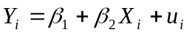 estimated using OLS the following statement is wrong ( – the residuals):
- 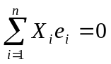;
- 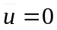;
- 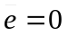;
- 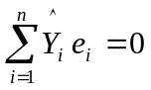;
- 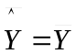.

- The linear model of expenditures for food 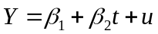 estimated using OLS as a function of time defined as 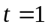 for 1959, 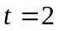 for 1960, ..., 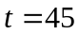 for 2003, is described as 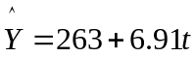. If the actual dates 1959 - 2003 would be used as time indicators, then and 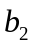 (the estimates of 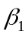 and 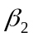) would be equal to:
- 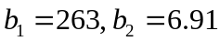;
- 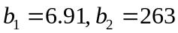;
- 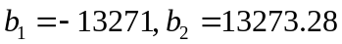;
- 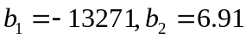;
- not enough information for finding and .

- Using the data of a sample with 80 observations, a student has estimated two regressions:
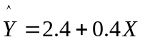 and
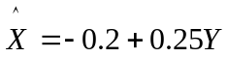
The determination coefficient in the first equation 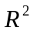 equals:
- 0.4;
- 0.16;
- 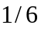;
- 0.1;
- there is not enough information for calculating in the first equation.

- Adding of an observation to a simple linear regression model, estimated by OLS,
- does not change in the model;
- can increase or reduce the value of in the model;
- generally speaking, results in reduction of the determination coefficient 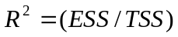;
- generally speaking, results in increase of the determination coefficient ;
- leads to impossibility to calculate in the model.

